After the recent flooding in Queensland and the frequent bush fires in Western Australia, an insurance agency decided to make better use of spatial information to evaluate the premium rate against the risk. Three datasets need to be created. One is to record land information for each land block for its boundary, the center of the approved building site(s), elevation of the center. The second data set is obtained from relevant government agency which mark the geographical regions affected by flooding and attached with each region is the risk classification of flooding "high", "medium" and "low". The third dataset record estimated fuel load (i.e. the total amount of combustible material in a defined space) for identified fire risk areas,
Question 1 [6 marks] Design a database for these three datasets. You may choose to use spatial data types such as POINT, LINE and POLYGON. This database should support at least the queries in Question 2 below. Use SQL create table statements to present your design. [Assume elevation is measured by the number of meters relative to the sea level, and fuel load is measured in units between 0 and 100. You can document other design assumptions if necessary.]
CREATE TABLE Land_Information (
boundary POLYGON,
approved_center POINT,
elevation FLOAT );

CREATE TABLE Flood_Region (
region POLYGON,
risk ENUM("high", "medium", "low");

CREATE TABLE Fuel_Load (
areas POLYGON,
fire_risk INT CHECK (fire_risk >= 0 and fire_risk <= 100));

Question 2 Write two queries in an SQL like query language,
(1) [3 marks] to find all the land blocks which are in the flooding region of high risk (including overlap) or whose elevation is lower than 10 meters of sea level.
(2) [3 marks] to find all high risk land blocks (defined as any land block with some area containing fuel load of 30 units or higher, or within 2500 meters of the area containing fuel load over 70 units)
[Please define any non standard SQL operations, relationships and constants you choose to use in a query]
SELECT L.boundary
FROM Land_Information As L, Flood_Region As F
WHERE (INTERSECT(L.boundary, F.region) == true AND F.risk == "high") OR L.elevation < 10;

SELECT L.boundary
FROM Land_Information As L, Fuel_Load As F
WHERE ((INTERSECT(L.boundary, F.areas) AND F.fire_risk >= 30) OR (DISTANCE(boundary, SELECT areas FROM FuelLoad WHERE fire_risk > 70) < 2500));

Operations Used:
INTERSECT(Argument1, Argument2) => BOOLEAN
The "INTERSECT" operation accepts two polygons and returns TRUE if FOR ALL POINTS x in Argument1 and y in Argument2, there exists a point such that x_{i} == y_{j} else false.
DISANCE(Argument1, Argument2) => Number
The "Distance" operation accepts two polygon returns the distance between them.
Question 3 Design a step by step query execution plan, which minimizes the data to be accessed in processing the query.
(1) [6 marks] to process the query you give in Question 2.1. Please make use of Z-value based spatial indexes.
SELECT L.boundary
FROM Land_Information As L, Flood_Region As F
WHERE (INTERSECT(L.boundary, F.region) == True AND F.risk == "high") OR L.elevation < 10;

L.boundary
Intersect(Land_Information.boundary,
Flood_Region.region) = T
F.risk == "high"
F.region
L.boundary
Land_Information
Fuel_Load
L.elevation < 10
The query execution plan for the above query is as follows:
- The DBMS query executor first parses the given SQL statement. If the statement contains any syntax error, it prompts the user regarding the error and the process halts. Else it continues to next step.
- The query optimizer calculates for the optimal cost of possible ways of returning the answer. From the diagram shown above, before performing the spatial join, F.region and L.boundary is fetched as shown in step 3 and 4. Our query is a spatial query which involves a spatial intersect join operation. According to [1], A spatial query optimizer has to take several parameters into account when choosing spatial join.
- All the records of Flood_Region.region is fetched such that its corresponding risk value is "high".
A = initializeEmptyList();
for i = 1 To last record of Flood_Region
if (Flood_Region[i].risk == "high")
addToList(A, Flood_Region[i].region);
end if
end for;
return A;

- All the boundary records are also selected such that its corresponding elevation is less than 10.

B = initialzeEmptyList();
for i = 1 To last record of Land_Information
if (Land_Information[i].elevation < 10)
addToList(B, Land_Information[i].boundary);
end if
end for;
return B;

- Then the spatial intersection is applied in two stages:
a. Filter Step: Since the computational costs involved in retrieving the right data is exponentially high, "The filter operates on approximations of the actual spatial descriptions of objects. This step aims at identifying inexpensively a set of candidate objects that are likely to satisfy the spatial predicate, while ruling out the major bulk of data not relevant for answering the query. Due to the approximation, the candidate set almost inevitably contains false drops, that is, spatial objects not satisfying the actual spatial predicate but the associated filter condition." [1]
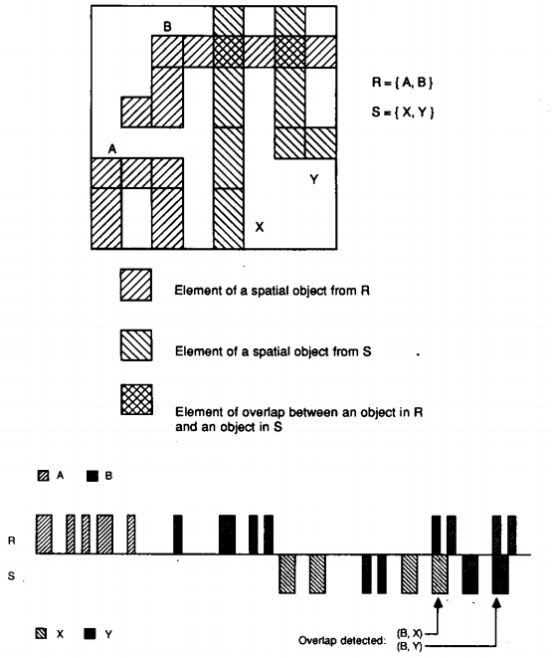
The image is from [2]
The z-value based spatial indices created on Land_Information.boundary and Flood_Region.region, help apply filter on spatial data. According to [1] the Z-ordering approximates a given object's shape by one or more cells, of different size. Each of these Peano cells is the result of a recursive decomposition of the embedding data space and can be canonically identified by a binary splitting sequence known as Z-value. These z-values can in turn be maintained by a ubiquitous one dimensional access method such as B+ tree. [1].
The logic of spatial join is as shown in the pseudo code below[3]:
A_{(Z)} = Get Z values for region in List A
for i = 1 To Last Element in A_{(Z)}
scan part of leaf sequence of "Land_Information" B+ tree having i OR i as prefix
C = collect all the candidates Land_Information.boundary in a list;

b. Refinement Step: It is necessary to fetch in a refinement step the actual spatial descriptions from disk and perform a precise test on them[1]. The refinement step eliminates the duplicate pair and also ensure to drop false results by checking which of the records from List B and List C are present in both of them.

k= 0; Solution = empty();
For i = 1 to end of list B;
for j = 1 to end of list C
if (B[i] == C[j])
Solution[k++] = AddTheRecordToFinalAnswer();
return Solution;

(2) [7 marks] to process the query you give in Question 2.2. Please use R-tree as spatial indexes.
SELECT L.boundary
FROM Land_Information As L, Fuel_Load As F
WHERE ((INTERSECT(L.boundary, F.areas) AND F.fire_risk >= 30) OR ( DISTANCE(boundary, SELECT areas FROM FuelLoad WHERE fire_risk > 70) < 2500));

L.boundary

OR

Intersect(L.boundary, F.areas) == True
Distance(boundary, F.areas) < 2500

L.boundary
F.areas
L.boundary
F.areas
F.fire_risk >= 30
Land_Information
fire_risk > 70
Land_Information

Fuel_Load
Fuel_Load
Part 1
Part 2

The query execution plan for the above query is as follows:
- The DBMS query executor first parses the given SQL statement. If the statement contains any syntax error, it prompts the user regarding the error and the process halts. Else it continues to next step.
- The query optimizer starts calculating the optimal cost involved in retrieving the request data. This query involves to two Spatial operations as shown in the diagram above. (Intersect and Distance)
- The query is processed in a bottom up fashion. That is the inner most parenthesis of the WHERE CLAUSE is executed. Either the Part 1 or Part 2 is executed first and then the other. After the execution of both parts 1 and 2, the INTERSECT and DISTANCE spatial operations are performed using the results of Part 1 and 2.
- In Part A, all records from Fuel_Load.area column is fetched from the table "Fuel_Load" such that Fuel_Load.fire_risk >= 30. Assume no non spatial index is present, and the data is fetched sequentially
A = initializeEmptyList();
for i = 1 to Last Record of Fuel_Load
if (Fuel_Load[i].fire_risk >= 30)
addToList(A, Fuel_Load.area);
return A; //L is the list with Fuel_Load.area records such that its corresponding fire_risk >= 30

Also all the boundary records are fetched from the Land_Information table so that the Intersect operation can be performed.

- The intersect operation is a spatial operation for which the inputs are the records from list A and L.boundary records. These two inputs are assumed to have the R-Tree indexed. An R-tree represents a hierarchy of nested rectangles, each of which corresponding to a disk page. If a disk page is an interior node, the intervals corresponding to the descendants of the node are entirely contained in the interior node's interval. Intervals at the same tree level may overlap. If it is a leaf node, the interval represents the minimum bounding rectangle (MBR) of the objects stored in the node. For each spatial object in turn, the page only stores its MBR and a reference to the complete object description.[1]
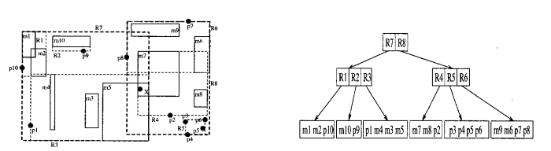
The Intersect operation using R tree is performed as shown below:
Input: Intersect(Fuel_Load.areas -> root of tree, Land_Information.boundary -> root of tree, emptyList L)

Function Intersect(tree1_node, tree2_node, List) : Output is the list of boundary of Land_information
for i = each child of tree1_node
for j = each child of tree2_node
if (meets(i,j) == true)
//Check if they are the MBR of objects and also present in List "A"
if (ischild(i) == true && ischild(j) ==true && isPresent(A,i))
addToList(List, j); //We need only Land_Information.boundary
else
//If two parent MBRs Intersect then their child also MAY intersect
Intersect(child(i), child(j)); //Depth first recursive search
end outer if
end inner for loop
end outer for loop
End Function

meet(argument1, argument2) : returns true if boundary of one rectangle intersects the boundary of the other. This is done by checking the co-ordinates of both MBRs.

isPresent(A,i) checks if i node's object is present in A to ensure F.area with F.fire_risk >= 30 is also evaluated.

The result is contained in "LIST", is the boundary of Land_Information which intersects with the Fuel_load areas whose fire_risk >= 30. Let us call this "LIST" as "X" so that we will reference in last step.

- In Part B, all the records of areas from table Fuel_Load are fetched such that fire_risk > 70
B = initalizeEmptyList();
for i = 1 To Last Record of Fuel_Load
if (Fuel_Load[i].fire_risk > 70)
addToList(B, Fuel_Load[i].area);
return B;

- Continuing the query process, the next action in bottom up approach is that all the records of boundary is selected from Land_Information such that its distance from the list B is < 2500. The spatial operation Distance is performed as shown below.

C = initializeEmptyList();
for i = 1 To LastRecord of Land_Information.boundary
for j = 1 To Last Item in the List B
if (distance_between(boundary[i],B[j]) < 2500)
addToList(C, Land_Information[i].boundary);
end inner for loop
end out for loop
return C;

distance_between(polygon1, polygon2): Calculates the distance between the two polygons in the following way:
polygon1(Xmin, Ymin) = getMinXYFromMBR(polygon1);
polygon1(Xmax, Ymax) = getMaxXYFromMBR(polygon1);
polygon2(Xmin, Ymin) = getMinXYFromMBR(polygon2);
polygon2(Xmax, Ymax) = getMaxXYFromMBR(polygon2);
polygon1Center(X,Y) = (polygon1(Xmin, Ymin) + polygon1(Xmax, Ymax)) / 2;
polygon2Center(X,Y) = (polygon2(Xmin, Ymin) + polygon2(Xmax, Ymax)) / 2;
Distance = SQRT((polygon1center(x) - polygon2center(x))² + (polygon1center(x) - polygon2center(x))²)
return Distance;

- Finally in the refinement step, the list C and list X are combined using OR operation, and any duplicates are eliminated returning the requested "L.boundary" values.

References:
1. Caching Strategies for Spatial Joins - DAVID J. ABEL, VOLKER GAEDE*, ROBERT A. POWER, AND XIAOFANG ZHOU [Received June 10, 1998; Revised October 5, 1998; Accepted November 20, 1998]
2. PROBE Spatial Data Modeling and Query Processing in an Image Database Application - Jac A PRENSTEIN AND FRANK A MANOLA [IEEE: TRANSACTIONS ON SOFTWARE ENGINEERING, VOL14, NO 5, MAY 1988]
3. Spatial Database Systems - Tutorial Notes Ralf Hartmut Güting, Fernuniversität Hagen, Praktische, Informatik IV, D-58084 Hagen Germany

